|  |  |
| --- | --- |
| C:\Users\e0294398\Pictures\EGC Upward & Onward Logo.jpg | Student Name _______________________  **Eastern Goldfields College**  Mathematics Methods Year 11 2019  Investigation 1 Validation Properties of Quadrilaterals 1 |

**Total Marks: 36 Time Allowed: 50 minutes**

**Question 1 (16 marks)**

**(6 marks)**

(a) A parallelogram with vertices *A, B, C* and *D* has three known coordinates A(0, 0), B(3, 4) and C(7, 7)



One definition of a parallelogram states that

“A parallelogram is a quadrilateral with opposite sides parallel.”

(i) Use the fact that “*opposite sides are parallel*“ to determine the coordinates of point D. Show your working. (7)

(ii) Determine the coordinates of the midpoint of the diagonals and comment on your findings. (3)

(b) (i) Is the parallelogram *ABCD* a rhombus? Justify your decision. (3)

(ii) Describe an alternative method that you could have used to show the parallelogram is a rhombus. (3)

**Question 2 (9 marks)**

The kite *ABCD* has coordinates *A*(2, 1), *B*(4, 3) and *C*(6,1) and AC is bisected by BD at Z. BD is 7 units in length.

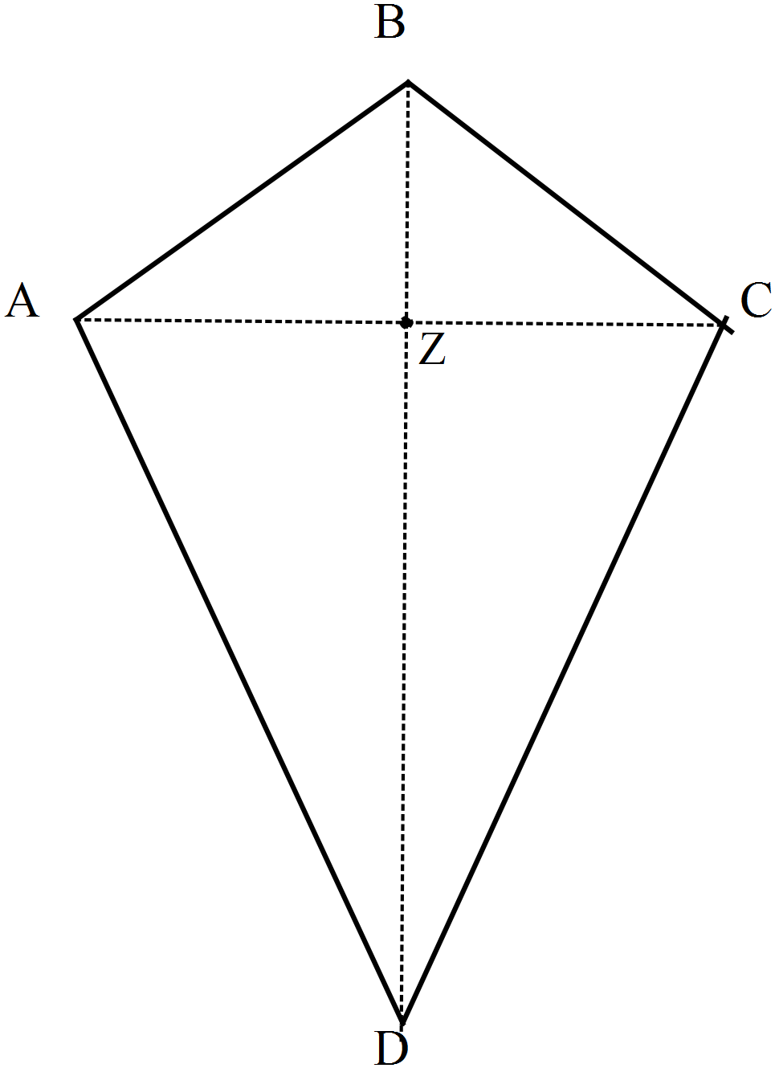

(a) Show that AB = BC (2)

(b) Show that AB is perpendicular to BC (3)

(c) Explain why DZ is 5 units in length. (2)

(d) Determine the coordinates of *D.* (2)

**Question 3 (7 marks)**

A second kite, with vertices *P,Q,* R and S*,* has known coordinates *P*(1, 3), *Q*(4, 6) and *R*(9,6).

The diagonals *PR* and *QS* meet at *Z* such that *QZ : ZS* = 1 : 3

(a) Draw a labelled diagram to represent the situation. (2)

(b) Determine the coordinates of Z (1)

(c) Hence, determine the coordinates of S. (4)

**Question 4 (4 marks)**

A third kite, with vertices J(0,0), K(*a, b*), L(2*a*, 0) and M(*x, y*) determine the values of *x* and *y* in terms of *a* and *b* given that the kite is also a rhombus.